**Project Design Phase Proposed Solution**

| Date | 27 June 2025 |
| --- | --- |
| Team ID | NM2025TMID00377 |
| Project Name | Calculating Family Expenses using Service Now |
| Maximum Marks | 2 Marks |

**Proposed Solution:**

| **S.No.** | **Parameter** | **Description** |
| --- | --- | --- |
| 1. | Problem Statement (Problem to be solved) | In ServiceNow, users assigned to incidents can  Many families struggle to track and manage their monthly expenses effectively. Without a centralized system, it becomes difficult to monitor spending patterns, categorize expenses, and maintain financial discipline. This leads to budget overruns, lack of financial visibility, and difficulty in making informed financial decisions. |
| 2. | Idea / Solution description | A custom ServiceNow application is created with a user-friendly interface to record and categorize family expenses. The application includes forms for expense entry, automated calculations, category-wise breakdowns, and visual reports/dashboards to help families track their spending patterns and stay within budget. deletion is blocked with an error message. |
| 3. | Novelty / Uniqueness | It addresses a critical real-world ITSM issue in a simple and effective way using native  ServiceNow logic (no external plugins needed). |
| 4. | Social Impact / Customer Satisfaction | It ensures better accountability and reliability for IT support teams, avoiding mistakes that lead to process breakdowns. |
| 5. | Business Model (Revenue Model) | Not applicable directly, but can save time, reduce data corruption, and avoid  miscommunication — leading to cost-effective ITSM operations for companies. |
| 6. | Scalability of the Solution | The solution can be extended to include other modules like Change Requests or Problem  Tickets. It can also be adapted for role-based restrictions in large teams. |

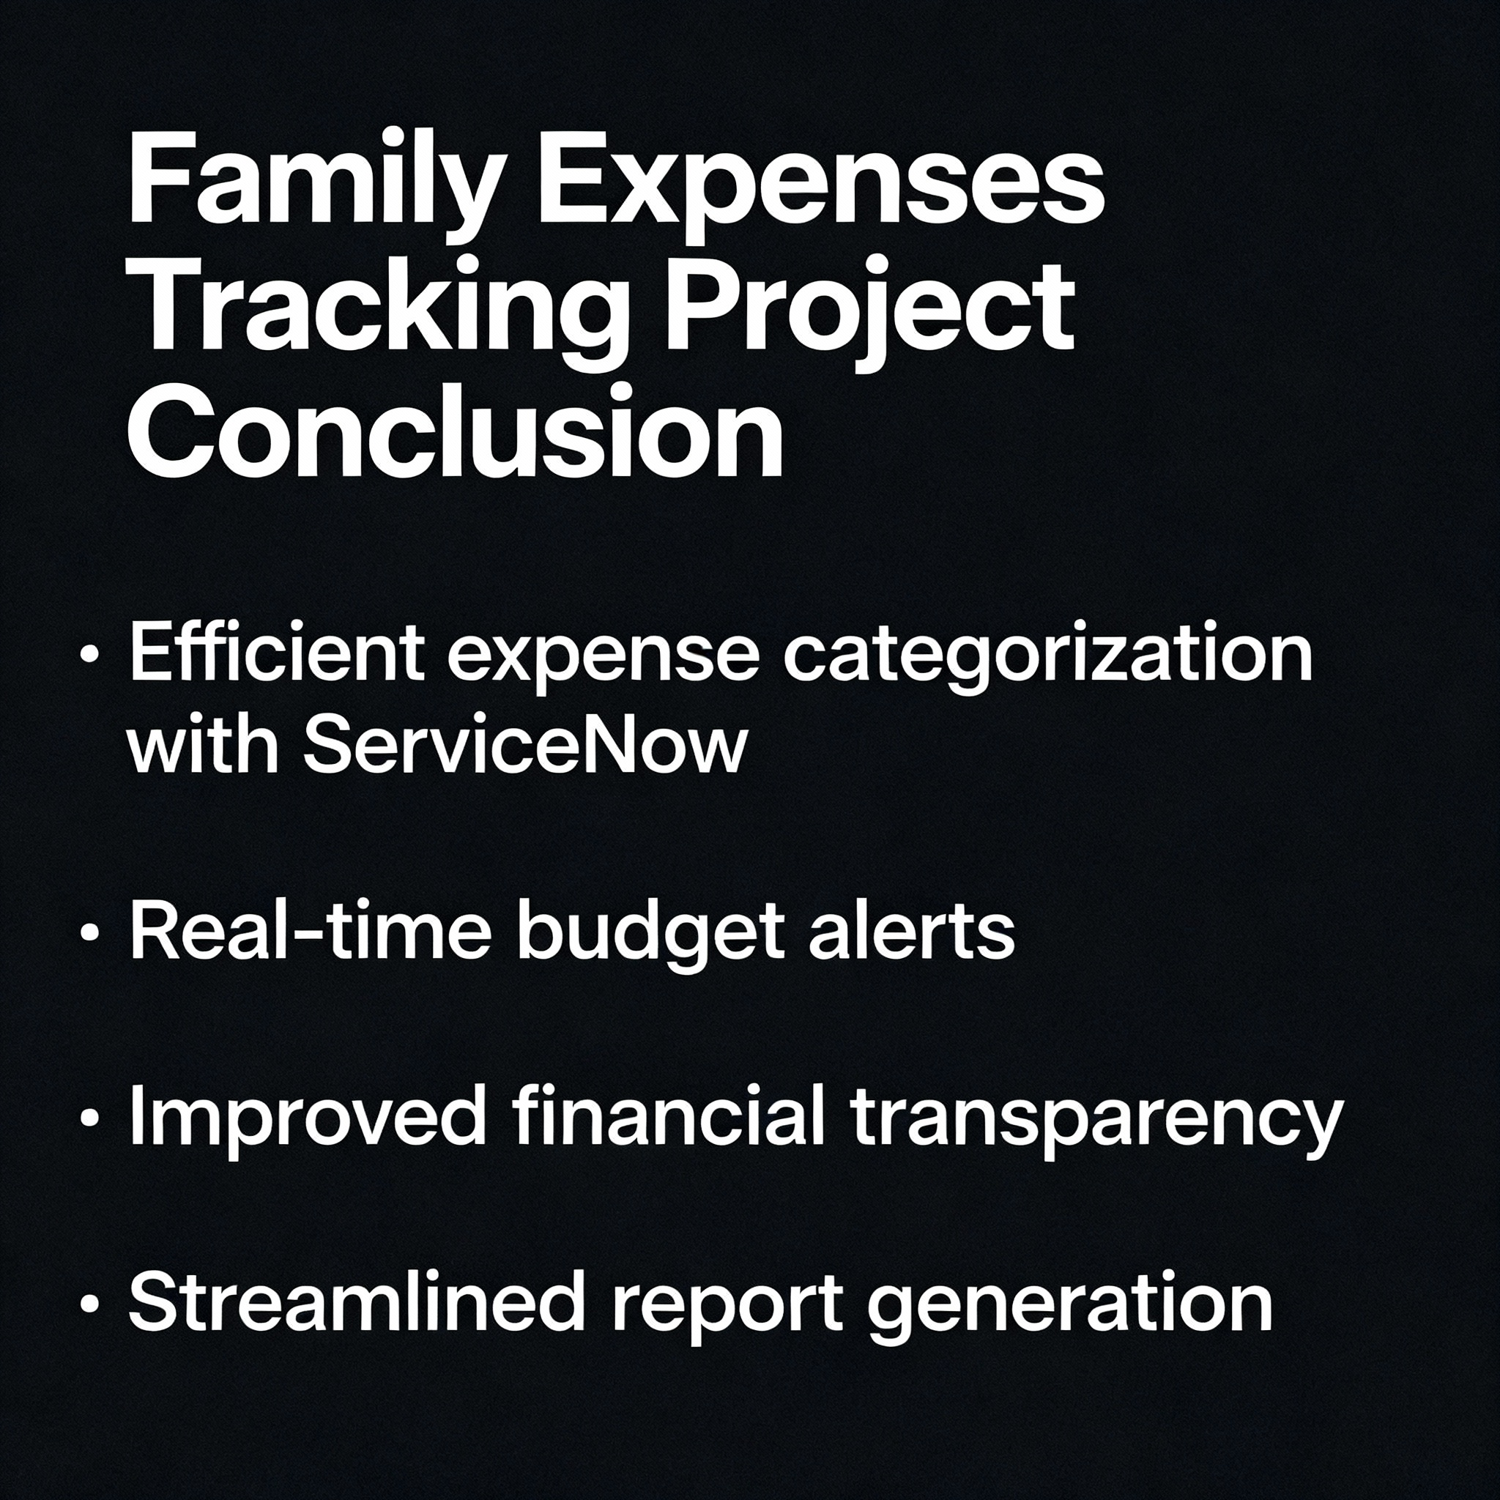

**Solution Description:**

To help families effectively track and manage their monthly expenses, a custom ServiceNow application is developed. This application provides an intuitive interface where family members can log their daily expenses, categorize them (such as groceries, utilities, transportation, entertainment, etc.), and view real-time spending summaries. The system includes automated calculations that aggregate expenses by category and time period, visual dashboards with charts and graphs for easy analysis, and budget alerts to notify users when spending approaches set limits. This solution leverages ServiceNow's platform capabilities to create a centralized, accessible, and user-friendly expense management system that promotes financial awareness and helps families make informed budgeting decisions.